Name of the experiment:Solve the non_linear system of equations using NR method.

Program code:

clc

clear all

x=1.5;

y=3.5;

display('It No. U V X Y');

for i=1:1:100

u=x^2-y^2-3;

v=x^2+y^2-13;

a=2*x;

b=-2*y;

c=2*x;

d=2*y;

xn=x-(((u*d)-(v*b))/((a*d)-(b*c)));

yn=y-(((v*a)-(u*c))/((a*d)-(b*c)));

if(u<=.001 && u>=-.001 && v<=.001 && v>=-.001)

break;

end

fprintf('%d %f %f %f %f\n',i,u,v,xn,yn)

x=xn;

y=yn;

end

Workspace :

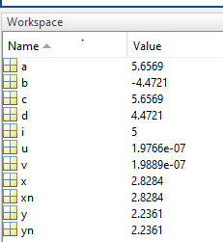

Command Window:

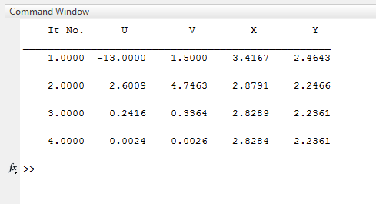

Discussion: Discussion: In this experiment we solve a complex equation very easily using Newton Raphson method. NR method is very useful and the convergence to the root can be done very easily. But one of the main disadvantage of the method is that if the derivative value of the equation is 0 then we can not use it in the NR formula.